**Data Structures and Algorithms**

**Lab Report**

**Lab10**



|  |  |
| --- | --- |
| Group Members Name & Reg #: | **Muhammad Haris Irfan**  **(FA18-BCE-090)** |
|  |  |
| Class | Data Structures and Algorithms CSC211 (**BCE-3B**) |
| Instructor’s Name | Dilshad Sabir |

**In Lab Tasks**

**Task:1**

**Your Task is to complete the ‘Node Deletion’ Function.**

**Solution:**

The code is shown below,

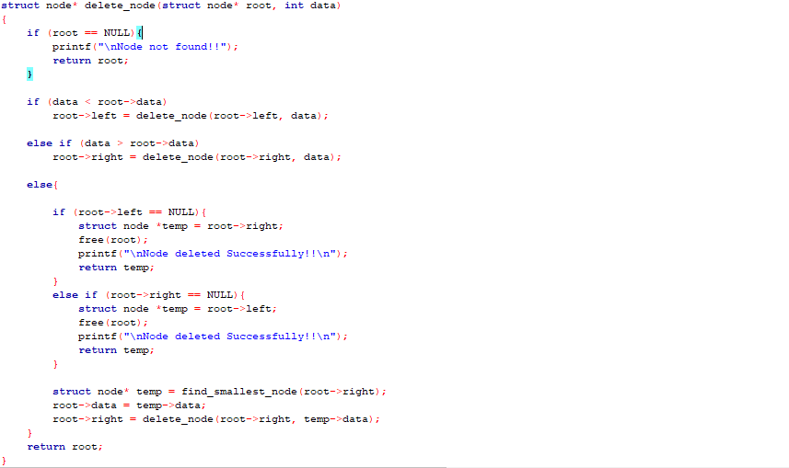

The Result of the following code is attached below:

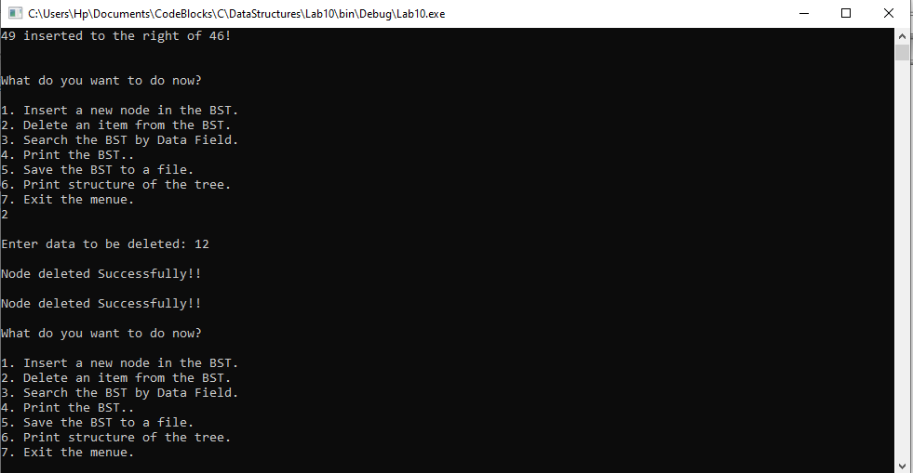

-------------------------------

**Task:2**

**Your Task is to complete the ‘Node Search’ Function.**

**Solution:**

The code is shown below,

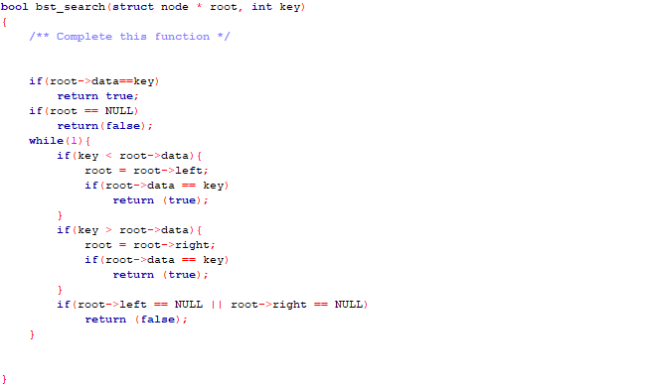

The Result of the following code is attached below:

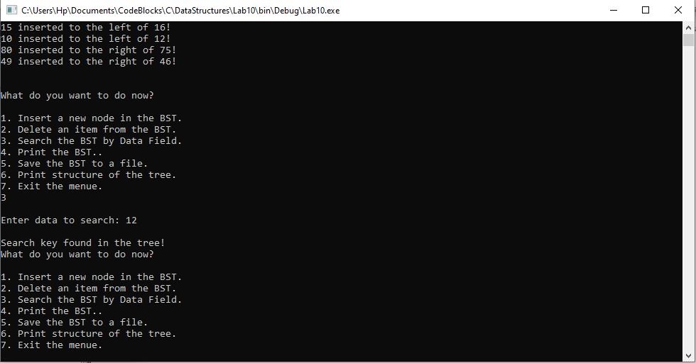

-------------------------------

**Task:3**

**Your Task is to complete the ‘Pre-Order’ and ‘Post-Order’ Printing Functions.**

**Solution:**

The code is shown below,

**Pre-Order** 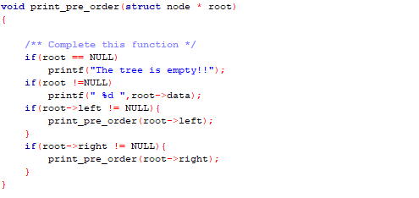

The Result of the following code is attached below:

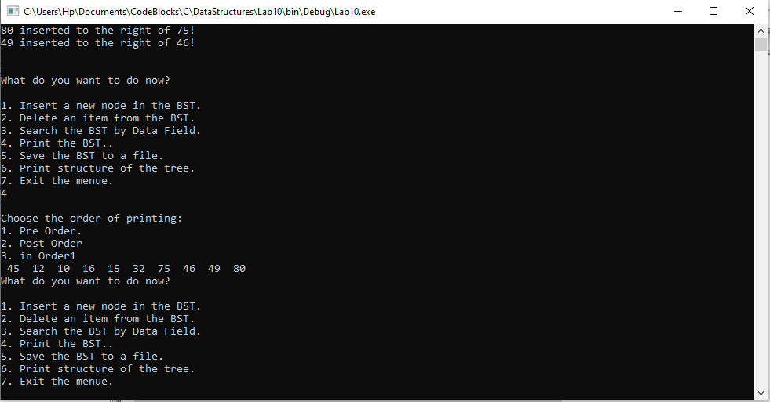

**Post-Order**

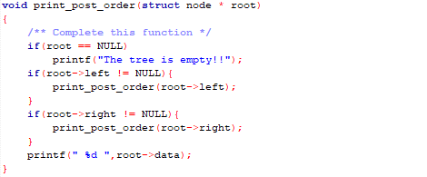

The Result of the following code is attached below:

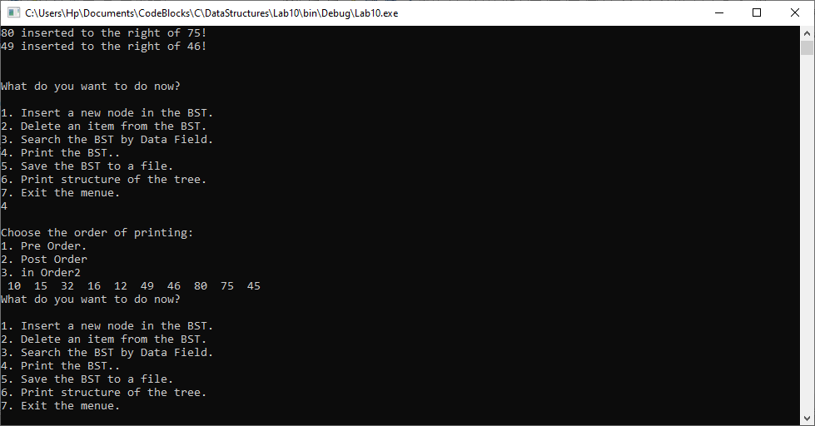

-------------------------------

**Post Lab Task.**

**Task 4:**

**Save the Tree data to a file (In-Order, Pre-Order and Post-Order)**

Solution

The code is shown below,

In-Order

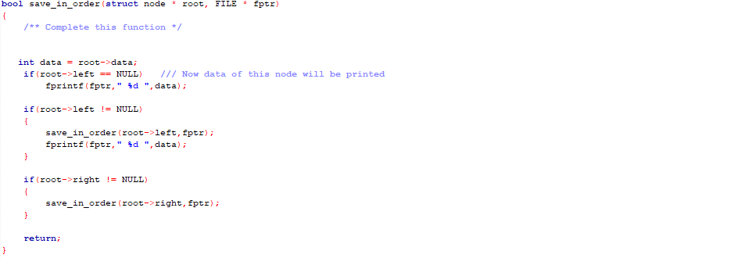

Pre-Order

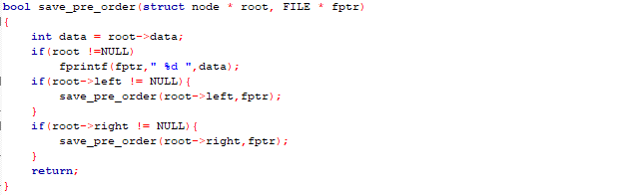

Post-Order

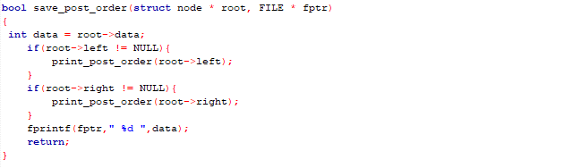

------------------------------

**Task 5:**

Load tree from a file containing numbers.

Solution

The code is shown below,

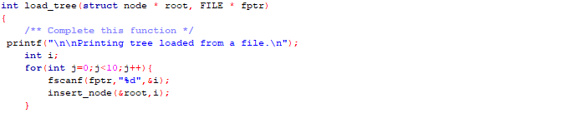

The Result of the following code is attached below:

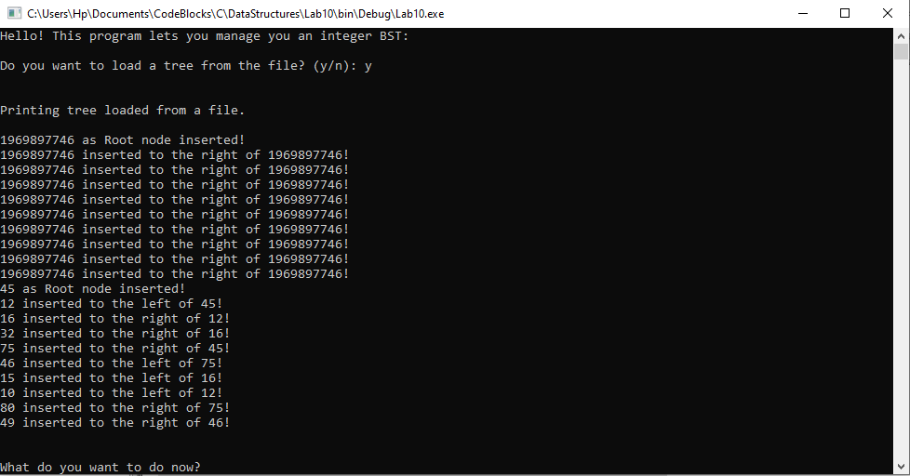

**Conclusion:**

In this lab, we implemented the functions to search, delete and print the Binary Search Tree, furthermore in Post-lab we implemented saving the Binary Search Tree as well as loading a tree from a file containing numbers.

------------------------------

THE END